
Available online at www.sciencedirect.com
SCIENCE /THF) DIRECT"
Future Generation Computer Systems 22 (2006) 688-698

www.elsevier.com/locate/fgcs
GMPLS-based service differentiation for scalable QoS support in all-optical
Grid applications
Francesco Palmieri *
Universita degli Studi di Napoli Federico II., Via Cinthia 45, Complesso Universitario Monte S. Angelo, Napoli, 80126, Italy
Received 6 September 2005; received in revised form 19 November 2005; accepted 21 November 2005
Available online 9 January 2006
Abstract
In the forthcoming new era of truly distributed computing, industry, businesses, and home users are placing complex and challenging demands on the transport network, now powered by the emerging photonic technologies, about Quality-of-Service (QoS) assurances that are required for new real-time computing and storage service applications geographically distributed worldwide according to the Grid model. There is the need to devise mechanisms for QoS provisioning in IP over WDM networks that must consider the physical characteristics and limitations of the optical domain to ensure the proper treatment of service classes when passing from the electrical switching to the optical domain and back. In addition, these mechanisms should be directly accessible to Grid applications to make them able to request and release network resources as they need. A (G)MPLS-based control plane combined with a wavelength-routed optical network is seen as a very promising approach for the realization of transport infrastructures for the future "photonic empowered" Grid computing paradigm, since it allows native user-controlled bandwidth resources and class-of-service provisioning, that is one of the strongest requirements for truly distributed computing. Considering this, we propose a general framework for providing differentiated services QoS to Grid applications in wavelength-routed photonic networks, built on the strengths of GMPLS for dynamic path selection and wavelength assignment. This framework makes it technically and economically viable to think of a set of computing, storage or combined computing storage nodes coupled through a high-performance optical network as one large computational and storage device.
© 2005 Elsevier B.V. All rights reserved.
Keywords: Grid computing; GMPLS; QoS; DiffServ; Optical transport networks; WDM
1. Introduction
Over the past years, it has become evident to the technical community that computational resources cannot keep up with the demands generated by some processing and data storage bound applications. Furthermore, the Internet, with the IP protocol as the most predominant networking technology, is evolving from best-effort service toward a differentiated service framework with QoS assurances which will be necessary for these applications, such as real-time particle physics experiments or radio astronomical image processing that produce more data than can be realistically processed in a reasonable time and stored in one location. In such situations where time-bounded intensive computation analysis of shared
Fax: +39 081 676628.
E-mail address: Francesco.Palmieri@unina.it.
large scale data is needed, one can try to use accessible computing and eventually storage resources distributed in different locations, according to the Grid model. Distributed computing and storage is not a new paradigm but until a few years ago networks were too slow, and the early days' best-effort networking paradigm was not adequate to allow efficient use of remote resources. As the speed of networks increased and technical strategies for differentiation in service delivery became available, the interest in distributed computing has been taken to a new level. Thus, scaling the network and delivering bandwidth and services when and where a customer critical application needs it, are absolute prerequisites for success. A new network foundation is required, that will easily adapt to support the rapid growth, change and highly responsive service delivery required by Grid computing. In this scenario, the wide deployment of point-to-point wavelength division multiplexing (WDM) transmission systems in the Internet infrastructure has enhanced the bandwidth available in the
network core by several orders of magnitude, introducing the need for faster switching in the optical domain. Consequently massive interest has focused on optical networking such that the answer to all the current performance open issues is conceived to lie in an intelligent dynamic photonic transport layer deployed in support of multiple, global, next generation Grid applications that are being designed and developed as highly asymmetric, highly distributed and resource intensive (e.g., computationally intensive, bandwidth intensive, etc.). New optical devices like WDM Multiplexers and Optical Cross-Connects (OXCs), and new control-plane protocols such as Generalized Multi-protocol Label Switching (GMPLS) [1] will make possible a pure photonic network where packets are routed through the network core without leaving the optical domain. The wavelength routing technology is considered extremely promising for the realization of new generation networks that will have to handle a significant portion of Grid applications' traffic, demanding specific resources such as assured QoS. These applications must have powerful and flexible network integration capabilities for directly discovering and signalling for use of the networking resources that they require, triggering the dynamic provisioning of virtual traffic tunnels throughout the network, such as multi-wavelength lightpaths and multi-domain (electronic and optical) label/lambda switched paths (LSPs). In addition, there is a need to devise the proper mechanisms for QoS provisioning in wavelength routed networks that consider the physical characteristics and limitations of the optical domain without any loss in flexibility and performance. The best solution, at our advice, is applying optical technologies and electronic technologies in different spheres by implementing QoS at the edge of a network with electronic technologies and mapping the resulting QoS service classes into separate lightpaths in the network fully-optical core. In this paper we present a general framework for providing differentiated services QoS in photonic-based Grid infrastructures built on the strengths of GMPLS for dynamic path selection and wavelength assignment. State-of-the-art optical networking technology based on dynamic wavelength switching enables the creation of Grid services that allocate and release these paths either on-demand or by advance reservation. Specifically, we focus on the edge lambda switching routers (LSRs), located between label (electronic) switching domain and lambda (optical) switching domain. All the QoS requirements of the client Grid applications located on the network edge, and consequently committed in the label switching domain, will be fulfilled by the appropriate allocation of particular wavelengths on concatenated physical resources, or lightpaths, in the lambda switching domain. This framework makes it technically and economically viable to think of a set of computing and storage nodes connected through a high-performance optical network as one large computational device so that the boundaries between applications, computers, and networks truly dissolve. The paper is organized as follows. Section 2 introduces the technological scenario and the most important prerequisite concepts while Section 3 presents the main architectural details such as the transport network model and the Grid Service interface. Section 4 explains the QoS provisioning scheme that is analyzed through extensive simulation in Section 5, followed by the related works Section 6.
2. Basic concepts
This section introduces some of the basic concepts that will be useful to better explain our framework.
2.1. High-performance Grids
High-performance Grids are part of a next generation "cyberinfrastructure", often used for extremely large-scale, resource intensive applications. These Grids are "persistent environments that enable software applications to integrate instruments, displays, computational and information resources that are managed by diverse organizations in widespread locations" [2]. Some emerging Grid infrastructures, such as the TeraGrid [3], use networks not for standard communications support but as backplanes for high-performance computational clusters, comprised of hundreds or thousands of individual compute nodes within widely distributed clusters. Other emerging infrastructures envision global services based on data communications infrastructure that is primarily dependent on layer 2 transit end-to-end as opposed to routed paths. The "Global Lambda Grid" [4], a concept that is being formulated by the StarLight community, envisions a Grid infrastructure based on world-wide wavelength data communications supporting multiple advanced applications, including high-performance computational scientific research, high-energy physics, engineering, bioinformatics, high-resolution medical imaging, materials sciences, data streaming, digital media, data mining, and astrophysics. The use of the available fiber infrastructure for the future global Grid transport network is an attractive proposition ensuring global reach and huge amounts of cheap bandwidth. In the last years, fiber networks have been great enablers of the World Wide Web services fulfilling the capacity demand generated by Internet traffic and providing global connectivity. In a similar way optical technologies are expected to play an important role in creating an efficient infrastructure for supporting distributed computing and bandwidth hungry Grid applications.
2.2. The evolution of transport networks suitable for Grids
An important consideration that would influence optical Grid network architecture is the choice of switching technology and transport facilities. Due to the nature of the applications supported by global Grid computing, suitable network infrastructures are required to offer a set of features that are very different compared to traditional telecommunications infrastructures. In telecommunications networks, when a traffic demand arises, independent of the transport protocol, the routing mechanism or the associated algorithms used, there is always a predetermined pair of two discrete points that need to communicate in order to satisfy the traffic demand. This is fundamentally different in Grid scenarios, in which a particular end user or application may require to access computational or storage resources distributed on the network and needs to identify the availability of network resources to reach them. In this case only the source point is predetermined, while the destination has to be discovered and identified using intelligent mechanisms supporting advanced signalling schemes. An additional fundamental difference of Grids compared to conventional telecommunication networks relates to the bidirectionality of connections. In traditional telecommunication networks connections are most commonly bidirectional and the two directions demonstrate strong symmetry characteristics. In the Grid paradigm the two directions are also required. One direction enables the source to discover and access the network resources in order to submit a job or request for a data set. The opposite direction is required in order to extract the results or the requested data and deliver them to the user. However, the two directions can be decoupled and set up independently since, due to the network scenario and resource allocation scheme they may have a different set of requirements and features. The main issue while designing optical networks for distributed computing application is specifying the right transport and control facilities. The transport networks on which the actual distributed computing applications run are evolving from the traditional TDM paradigms, with WDM used strictly for fiber capacity expansion, toward pure WDM-based optical networks with transport, multiplexing, routing supervision, and survivability handled at the optical layer. These optical networks, to provide the infrastructures required for Grid applications, must be based on a distributed and flexible control plane allowing control and ownership of network resources by the users, in contrast to traditional telecommunications networks. The key concept to guarantee desirable speeds and correct functional behavior in these networks is to maintain the signal in pure optical form, preferably onto the same wavelength, thereby avoiding the prohibitive overhead of conversion to and from electrical form or between different wavelengths. In this scenario, given that the IP protocol framework will become the dominant form of data transfer, there is an increasing interest in the implementation of "Grid-aware" IP over photonic networks by using the wavelength-routed networking paradigm and placing Grid data services directly on WDM lightpaths. A very large consensus is also emerging on utilizing an IP-centric control plane within optical networks to support dynamic provisioning and restoration of lightpaths. Specifically, we assert that the GMPLS-based control plane, combined with DWDM technology, makes it possible to provide an effective framework for optical bandwidth management and real-time provisioning of QoS-bound optical channels in an automatically switched, transparent optical network suitable for next generation high-performance distributed computing applications.
3. Optical transport infrastructures for Grids
In optical network infrastructures supporting Grids, high bandwidth users and applications must manage and control network resources, in a distributed and truly peer-to-peer manner. The optical transport networks must support bandwidth manipulation at the wavelength level through wavelength switching technologies, offering not only high switching granularity but also the capability to accommodate a wide variety of traffic classes, characteristics and distributions. Novel control plane designs and hardware solutions ensuring the programmability of the network infrastructure can facilitate dynamic control of bandwidth and service classes to support new application-oriented and user-owned network infrastructures. In these networks resource request, discovery and allocation functions have to be performed initially when a processing requirement (i.e. bandwidth demand) arises. For example if a certain number of users (or applications) have jobs to be posted on the Grid, each one constructs a "request" indicating the amount of processing and the class of service required. These requests, translated in terms of network resources and QoS needs by the proper Grid-to-network interface middleware, are received by the ingress point at the edge of the network (typically hybrid optical routers, performing optical-to-electrical (O/E) and electrical-to-optical (E/O) conversions) and assuming that the total volume of the data to be processed is large enough, a bandwidth and QoS request arises at the optical layer. In the case of acceptance, the data itself is immediately allowed in the network making use of available resources i.e. wavelengths. The intermediate optical switching nodes (typically OXCs), making up the "core" of the optical transport network, are not notified in advance of the arrival (i.e. there is no advanced reservation), but decide on the fly where to forward the data. These intermediate nodes will clearly require some application and network-level awareness in order to configure the resources that are best suited for the particular task. The above connectivity service may be provided over a private or public shared network (like the Internet) owned by a large enterprise or a consortium (a Grid consortium, for example) or spanning many different service providers or carrier organizations. Anyway, to facilitate on demand access from Grid applications to the optical transport network and consequently to the specific Grid services, interoperable procedures between Grid users and the optical network for service-level agreement negotiation and user job submission have to be developed. These procedures constitute the so-called Grid User Network Interface (GUNI). Since the Grid infrastructure and services are usually managed by a resource management system or middleware, such as Globus, the GUNI interface is usually integrated within this middleware stratum. The GUNI also provides a simple signalling mechanism between Grid users and the optical network following the indirect service invocation scenario, in which the users request the network edge devices for a Grid service (i.e. bandwidth reservation or service class) through a Grid service agent. This agent performs the above functionalities by sending proper control parameters/action codes to the network edge devices according to a well defined protocol.
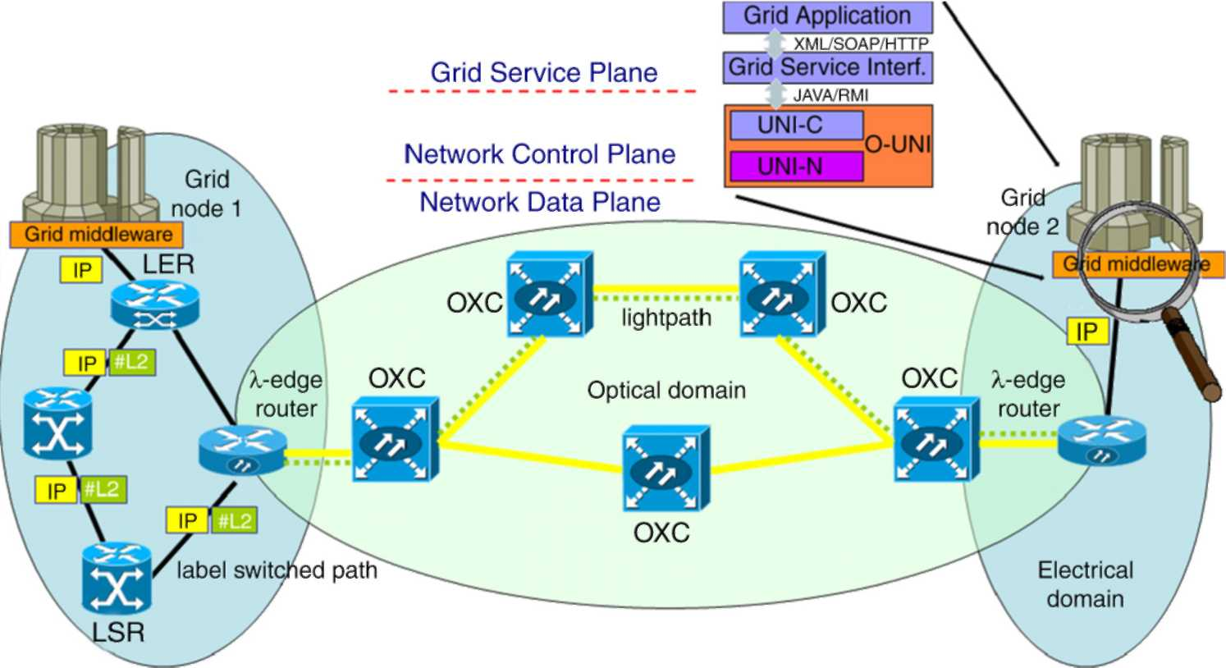
Fig. 1. The GUNI architecture.
3.1. The GUNI architecture
The Grid applications typically need to allocate and reserve multiple types of resources, such as computational, data, instrumentation, and locally scoped networks, at distributed sites. To enable the efficient use of optical networks as a primary resource for these applications, a powerful paradigm for the reservation and dynamic allocation of individual wavelengths, directly available into the Grid middleware, is required. This paradigm should rely on a new network service, made available through the GUNI, providing options for requesting, allocating and releasing dedicated network resources to Grid applications. This service must explore the availability and optimize the schedule of the optical network resources hiding to the client all the transport network topology and engineering details. It should also present a flexible, high-level interface to make the optical network infrastructure accessible through the Grid middleware. A natural choice for implementing this interface on the Grid host site is the Web Service Resource Framework (WSRF) [12] aiming at implementing some of the Open Grid Service Architecture (OGSA) core services as Grid services, or better, web services enhanced for Grid applications. Such interfaces are compliant with the GGF's OGSA specification [11] and, in addition, conform to widely used Web Services standards (WSDL, SOAP, and XML). On the hosts participating to the Grid, any given optical lightpath and its associated QoS capabilities could be modeled as a Grid service in a service oriented architecture like OGSA and implemented by using, for example, the Globus Toolkit v3 OGSA [11] as the development platform. An end-to-end lightpath requested by the Grid users could be treated as a network enabled entity, which provides a particular QoS capability. These capabilities will be defined within a WSDL file, where a client of the QoS-aware lightpath service will be able to discover and invoke supported operations. To break down the complexity, maintainability, development and operational sustainability of the GUNI model, its architecture can be conceptually divided into two tiers — the top level one, the Grid Service Interface, directly providing service to Grid applications, and the Optical Network Interface, providing access to the underlying transport network, as depicted in Fig. 1.
As a simple example we can define the application-level interface for the basic end-to-end lightpath on-demand allocation and deallocation service. It should allow the application to specify parameters of the desired optical path that are relevant at the application level, while hiding the details of the underlying network topology and network management protocols. Two methods need to be exposed to the user: Path-Request and Path-Release. The method Path-Request requests a new path between two end hosts. The path allocated should meet the criteria specified in the parameter object passed to the method. These parameters may include the network addresses of the hosts to be connected, the minimum acceptable bandwidths, the maximum delay, or Bit Error Rate (BER) and the maximum duration of the allocation. The Path-Request method returns to the caller an object containing descriptive information on the path that was allocated. This object also serves as a handle for the Path-Release request and in a very simplified implementation may also be used to mark, via the DiffServ DSCP field, the Grid traffic that will be explicitly routed on the specific path. This allows simple traffic classification and marking activities to be done at the GUNI level, enabling Grid users (or applications acting on their behalf) to directly micromanage network capacity and service class allocations at the Grid middleware level. Such a service can be implemented in a way that does not maintain any session or context information for any particular client between calls. The only necessary context information is the allocated path identifier, which the client is required to supply in order to deallocate a path. The service must maintain this information about these allocated paths so, in this sense, it is not "stateless", but each client call can be treated as a self-contained unit and processed entirely in a single-message exchange. Thus, the interface fits the service oriented architecture of Web Services quite closely.
3.1.1. The network service interface
Since the underlying transport network is usually neither owned nor under the control of the Grid organization we need an architecture where the interfaces between Grid network sites and the optical transport network is standardized and widely supported from network equipment manufacturers. In the proposed GUNI architecture, access to the optical transport network control plane will be available through an optical user-network interface (O-UNI) standardized by the Optical Internetworking Forum (OIF) [13]. O-UNI defines the optical interface between the service provider (optical transport network) and user client equipment, allowing a client at the edge of the network to signal for a connection to be set up or torn down. GMPLS will be used for client signalling. O-UNI functionalities have been implemented in UNI 1.0 [14] that specifies the set of services, the signalling protocols used to invoke the services, the mechanisms used to transport signalling messages and the auto-discovery procedures that aid signalling, all of which are to be implemented by client and transport network equipment vendors to support UNI 1.0. UNI 1.0 mainly focuses on signalling protocols such as RSVP (resource reservation protocol) [7] and CR-LDP (constraint-based label distribution protocol) [8] for service invocation and resource reservation. Proposed parameters available to the O-UNI include destination port, QoS, protection level, bandwidth, and route diversity. The interconnection model of our GUNI, interfacing the standardized O-UNI is an overlay model, with indirect service invocation configuration, Here, UNI-N (UNI Signalling Agent - Network Side) and UNI-C (UNI Signalling Agent - Client Side) components are needed at both sides, respectively on the Label Edge router (LER) and on the Grid interface. The purpose of the overlay model (O-UNI/GMPLS) is to enable the client (the Grid service requester) to add, modify, or delete connections to the carrier network, without providing the client any visibility to the carrier's network topology. The overlay model maintains a separation at the client-to-network interface by keeping the IP client routing, signalling protocols, topology distribution, and addressing scheme independent from the ones used by the optical layer of the carrier network.
3.1.2. The communication paradigm
Communication between the Grid applications and the GUNI top level service interface will take place via SOAP/HTTP using well-defined extended WSDL Grid Web service interface [15]. Requests and responses conform to WSRF Web Services specifications, i.e., they are SOAP messages, carried in HTTP envelopes and transported over TCP/IP connections. The Grid Service Interface can announce its services by means of a Universal data base Description, Discovery and Integration (UDDI). The optical network services can be made available to the Grid Service Interface through an OIF UNI 1.0 compliant UNI programmatic interface library (i.e. Java/RMI), interfacing the Client-side UNI signalling Agent (C-UNI) available on the Grid host. Using LDP or RSVP-TE signalling, as defined in UNI 1.0, connections triggered via the UNI-C agents may be automatically provisioned between two edge routers with optical interfaces, through the optical network composed of optical routers and OXCs. As an example, when using LDP signalling, operation mode in UNI will be downstream on-demand label advertisement with ordered control and thus when a new connection is needed, for example, for transmitting data between two remote Grid applications, the Source UNI-C (SUNI-C) sends an LDP request message to the corresponding network interface agent Source UNI-N (SUNI-N). If the optical network accepts the request, the Destination UNI-N (DUNI-N) relays the request message to the Destination UNI-C (DUNI-C) to reserve the required bandwidth. Supposing the reservation is successful, DUNI-C sends an LDP mapping message to DUNI-N with the assigned interfaces and labels; if the optical network commits the assignment, the SUNI-N relays the mapping message to SUNI-C. When SUNI-C receives the mapping message, a reservation confirmation message is forwarded to DUNI-C in a fashion like the initial request message. After completing the above signalling process, the Grid application achieves access to the required connection service through the optical core network.
4. QoS support in WDM-enabled Grid networks
Over the past decade, a significant amount of work has been dedicated to the issue of providing QoS in non-WDM IP networks. Basic IP, that is the network protocol of choice for the actual and past low-performance Grid architectures, assumes a best-effort service model. In this model, the network allocates bandwidth to all active users as best as it can, but does not make any explicit commitment as to bandwidth, delay or actual delivery. This service model is not adequate for many real-time new Grid applications that normally require assurances on the maximum delay of transmitting a packet through the network connecting the end points. Furthermore, with the recent migration of modern Grid applications from a Local Area Network (LAN) to a more global Wide Area Network (WAN) scenario, the need for strong quality assurance in the transport service has emerged. Indeed, unlike in the local Grid scenario, in the global Grid scenario applications should share network resources with a number of heterogeneous other applications whose required network service may vary from basic connectivity, like Internet access, to more complex services, like Virtual Private Networks (VPNs). Particularly, to support the emerging high-performance computational Grids, given the intrinsic heterogeneous nature of middleware and user applications running on them, at least two fundamental Quality of Service requirements are to be defined.
• Services for minimization of packet loss, packet instantaneous delay variation and one-way delay: Applications based on video streaming, voice, or on the exchange of high-quality images are examples of data-intensive transactions on the Grid that produce load on the network but are particularly sensitive to packet loss, delay and jitter. Remote control is another example of delay and packet loss-sensitive application, which injects a small amount of high-priority traffic.
• Services for segregation of different traffic classes:
Segregation of traffic classes is the capability to provide a given set of QoS guarantees to each traffic class regardless of the traffic profile injected. This type of service can be used for example to protect in each Grid site legacy traffic from data intensive applications like ftp bulk transfers that could potentially allocate the whole amount of access capacity. Less-than-best-effort services like the Scavenger service under definition for the implementation on the Abilene network are additional examples of services based on traffic segregation: they allow production/legacy traffic to use up to the total amount of link capacity without being impacted by lower priority data.
A number of enhancements have been proposed to enable offering different levels of QoS in IP networks; these enhancements can also be very useful in supporting differentiation in Grid services. This work has culminated in the proposal of the Integrated Services (IntServ) [5] and the Differentiated Services (DiffServ) [6] architectures by the IETF. IntServ achieves QoS guarantees through end-to-end resource (bandwidth) reservation for packet flows and performing per-flow scheduling in all intermediate routers or switches. DiffServ, on the other hand, defines a number of per-hop behaviors that enable providing relative QoS advantage for different classes of traffic aggregates. Both schemes require sources to shape and classify their traffic at the GUNI interface-level as a precondition for providing end-to-end QoS guarantees. Since Grid traffic will eventually be aggregated and carried over the core networks (often the Internet), it is imperative to address end-to-end QoS issues in WDM networks. However, previous QoS methods proposed for IP networks are difficult to apply in WDM networks mainly due to the fact that these approaches are based on the store-and-forward model and mandate the use of buffers for contention resolution. Currently there is no optical memory and the use of electronic memory in an optical switch necessitates O/E and E/O conversions, strongly limiting the speed of the optical switch itself. In addition, switches that utilize O/E and E/O converters lose the advantage of being fully optical and consequently bit rate transparent. However, the wavelength domain provides a further opportunity for contention resolution based on the number of wavelengths available, the wavelength assignment method and the unique optical quality characteristics of lightpaths. An end-to-end connection request carried into a single or multi-hop all-optical wavelength routed path can experience transmission errors, delay and packet loss. These parameters and behaviors provide the basis for measuring the quality of optical service available over a given path and for defining the classes of optical transport services made available to Grid applications. Our real objective is to implement a scalable and cost-effective transport network architecture able to satisfy their QoS requirements by decoupling the networking aspects from the service specifications. This separation permits one to preserve the existing infrastructure whenever new services or upgrades of the existing ones need to be established.
4.1. QoS-driven lightpath allocation
The problem of finding a route for a lightpath and assigning a wavelength to the lightpath is often referred to as the routing and wavelength assignment problem (RWA). The objective of the problem is to route lightpaths and assign wavelengths in a manner which minimizes the amount of network resources that are consumed, while at the same time fulfilling the paths' QoS requirements and ensuring that no two lightpaths share the same wavelength on the same fiber link. In general Lightpath allocation algorithms partition the available lightpaths into different subsets. Each subset is assigned to a service class. The allocation approaches differ from each other in the way lightpaths subsets are allocated to service classes. This allocation can be static, static with borrowing or dynamic. In the case of static allocation, a fixed subset of lightpaths is assigned to each of the service classes. The number of lightpaths in each of the subsets depends on the service class i.e. higher service classes are allocated more lightpaths. When borrowing is allowed, different priority classes can borrow lightpaths from each other according to certain criteria. However, borrowing in the reverse direction is not allowed because lightpaths originally assigned to lower priority traffic may not satisfy the QoS requirements of higher priority classes. In dynamic approaches, the network starts with no reserved lightpaths for service classes. The available pool of lightpaths can then be assigned dynamically to any of the available service classes, under the assumption that all lightpaths have similar characteristics.
4.2. GMPLS Label/lambda inferred DiffServ QoS
We propose a GUNI-driven approach to service-differentiated LSP/lightpath accommodation on a pure photonic switching core and mixed (electronic to optical) edge built on the GMPLS control plane and Differentiated Services. DiffServ is the basic building block for providing QoS within the modern networks and GMPLS has good synergy with the DiffServ paradigm because of some similarities in their elements, such as the role of the domain edge and the application of a treatment throughout the domain. The combination of GMPLS and DiffServ enables the operator to provide an optical network capable of supporting services with defined characteristic requirements throughout the electric and photonic domains and the ability to deliver them according to modern Grid applications' service-level agreements. For such a GMPLS-based network in which Label Requests are arriving and departing at high rates, an appropriate control scheme must be implemented to set up lightpaths for label distribution and data flow switching in a fast and efficient manner while fully satisfying the QoS requirements of the transported service classes. We will adopt a label-inferred QoS scheme for LSP setup in which all packets entering the LSP will be marked at the GUNI level with a fixed Class of Service value and the label associated by GMPLS to the packets specifies how they should be treated. This also means that all packets entering the LSP receive the same class of service. Stated in a more detailed way, each label switching router that contributes (in the electronic domain) to a hop to the LSPs has packet scheduling logic (PHB) that meets at each hop the QoS level defined by the provisioned DSCP. The ingress label switching router examines the QoS control parameters passed from the Grid users through the GUNI interface (that in the simplest case may be directly mapped in the DSCP field in the IP header) and selects a feasible label switched path that has been provisioned for that QoS level. In more complex cases, sophisticated additional parameters such as reserved bandwidth, link quality and lightpath protection requirements can be negotiated between the GUNI client and the edge router via proper signalling. Also in this case a class of service-DSCP mapping should be established prior to inject the traffic into the transport network. Anyway, each label switching router in the path examines the incoming label and determines, with the EXP field, the QoS treatment for the encapsulated packet. When entering the pure optical domain, the differentiated service operation of the edge lambda switching router or OXC is characterized by a set of particular control issues, such as provision of service-specific guarantees and fair accommodation of the transported types of services into corresponding lambdas such that DiffServ QoS in the optical domain is guaranteed by the appropriate allocation of particular service class-dedicated wavelengths on concatenated physical resources. More specifically, when a Label Request, triggering a path establishment on a GUNI-request basis, arrives from the label switching domain to the edge lambda switching router in the photonic domain, the incoming label determines the QoS treatment for the encapsulated packet so that an optical network service is assigned to the packet flow, capable of taking into account user requirements and available network resources. Then the basic problem is to find a route and to assign a wavelength to the Label Request that will satisfy the LSP QoS characteristics. If a wavelength cannot be found on the route from the source node to the destination node, or if there is insufficient capacity in the network, then the Label Request will be blocked. In the edge lambda switching router, the QoS condition as well as the capacity and availability of the optical network resources should be considered. Thus the procedure to set up the LSP in the lambda switching domain is closely related with the routing and wavelength assignment algorithm. Within the GMPLS scope, the OSPF or ISIS link-state internal routing protocols, properly modified with traffic engineering and RWA extensions, along with label distribution/signalling protocols such as RSVP with traffic engineering extension or CR-LDP, implements the required QoS-aware dynamic routing and wavelength assignment features, as described in the following sections.
4.3. The QoS-aware routing and path selection paradigm
According to the above schema, the optical network consisting of n nodes interconnected by m optical links, where each link can carry up to k wavelengths, can be modeled as a layered graph [9], where all the wavelengths on a link are separated into different graph edges. Each node in the network can be an LSR, a lambda-edge router with several WDM interfaces and wavelength conversion capability or a pure OXC without wavelength conversion capability. The SPF-based link-state routing algorithm used to dynamically route the connection requests (OSPF or ISIS, as stated before) properly crafted for wavelength routing tasks, works on such a graph which is modified after every successful connection. The layered graph, that we can call G, is obtained by expanding each node in the network into a number of virtual sub-nodes, one per wavelength, and then by connecting each sub-node to a wavelength on each incoming and outgoing link. Let us define as E the set of edges of this graph. LSRs and LERs are represented adding some "conversion" super-nodes, that topologically connect all lambda layers through "fictitious" links with infinite capacity. If the initial (full) capacity of each edge is normalized to 1, each time the routing algorithm finds a path between an ingress-egress pair in G we modify it by removing the graph edges traversed by a lightpath and by adding a direct edge, called cut-through, with capacity equal to 1 - Rb where Rb is the fraction of the link bandwidth required by the lightpath. The extended graph allows us to model the wavelength availability per link and the residual bandwidth per logical link at the IP layer. When an established lightpath is torn down because the last connection occupying it is ended, the cut-through arc is removed and the edges in the extended graph corresponding to the underlying physical links are set back with full capacity. Each edge in E is weighted by a triplet (Ab, w, c), where Ab is the available edge capacity (if Tb is the wavelength capacity in bandwidth units Ab = Tb means full capacity), w the associated weight and c the cost metric which models the signal degradation introduced by the transmission link, and may correspond to:
• an available wavelength X on a direct physical link between two nodes (in this case Ab = Tb and c = 1)
• an existent direct (cut-through) lightpath on a wavelength X between the nodes. For such an edge
M
Ab = Tb - Rbi
i = 1
where M LSPs with required bandwidth Rbi are running over it and c is set to the number of crossed fiber links)
• a fictitious conversion edge between the super-nodes in G (and thus it has Ab = oo and c = 0).
Different wavelength routing policies can be realized by modifying the w components on the weight triplets of the edges in E and then by running the Dijkstra shortest-path-first (SPF) algorithm on the extended graph. In fact, these weights may be used to reflect the cost of network elements such as O/E/O converters (in LSR or LER nodes) or free wavelengths on some link and to characterize the properties of different wavelength channels (such as delay, capacity, etc.). Thus, by modifying the above weighting factors according to the incoming service class request, it is possible to choose a path which minimizes the number of conversions or which maximizes the usage of existing lightpaths. The different decisions reflect different objectives in terms of network resource utilization. As a result, a request can be routed over a direct lightpath (a single-hop path at the IP level), if it crosses only nodes that cannot perform wavelength conversion between an ingress and an egress router, or over a sequence of lightpaths (a multi-hop path at the IP level), if it crosses nodes that are wavelength conversion capable (lambda-edge or routers as well). Note that a lightpath in the optical domain corresponds to a single wavelength crossing a certain number of nodes, without wavelength conversion. Simply stated, to satisfy a connection request with bandwidth Rb and class of service q we can first run the SPF algorithm on the above layered graph G by considering only the edges with residual capacity greater then Rb and weight w < q; otherwise, if no such a lightpath exist and a new one has to be set up the SPF algorithm should be applied on the graph G considering only the edges in E with cost c = 1 and weight w < q. In the worst case, when all the previous operation does not result in any available direct path, an indirect path, built on multiple lightpaths all with adequate capacity and QoS characteristics (as above) passing through a conversion edge can be chosen.
4.4. GMPLS signalling-driven wavelength assignment
Upon the arrival of a path establishment request, which is a Label Request indirectly triggered through the GUNI interface, an edge lambda switching router utilizes the topology information, gathered from the routing protocol link status and utilization information to select a route and a wavelength. Once a route and wavelength are selected with the help of the SPF algorithm on the above described layered graph structure, the node attempts to send a Label Request through the selected wavelength along each link in the route. Thus the Lambda-Switched paths of a certain service type are set up and released dynamically, under the quality constraints related to the optical paths. When exiting from the pure optical domain the transporting wavelength is naturally re-mapped into a class of service label (by using the EXP field) according to the GMPLS control plane paradigm and at the egress label switching router the last label is removed and the packet is sent to the next IP hop with its original DSCP. This scheme requires that an association of specific DiffServ code points to label switched paths be pre-established prior to traffic flow. This can be accomplished through proper configuration at the GUNI interface level. In more detail, when RSVP is used, signalling takes place between the source and destination routers. At the source, a Path message is created and sent to the destination node (see Fig. 2). It may be routed step-by-step according to the above wavelength routing protocol decisions through the selected lightpath. Alternatively, an explicit route through the network may be specified if the source router is aware of the network topology. The Path message contains QoS requirements' information for the carried traffic and lambda requests for assigning/reserving wavelengths at intermediate nodes. On each intermediate node, typically an OXC or LER, the request is recorded and the Path message is forwarded to the next node. If the message cannot be forwarded or if resources are not available, the path setup fails, and a message is sent back
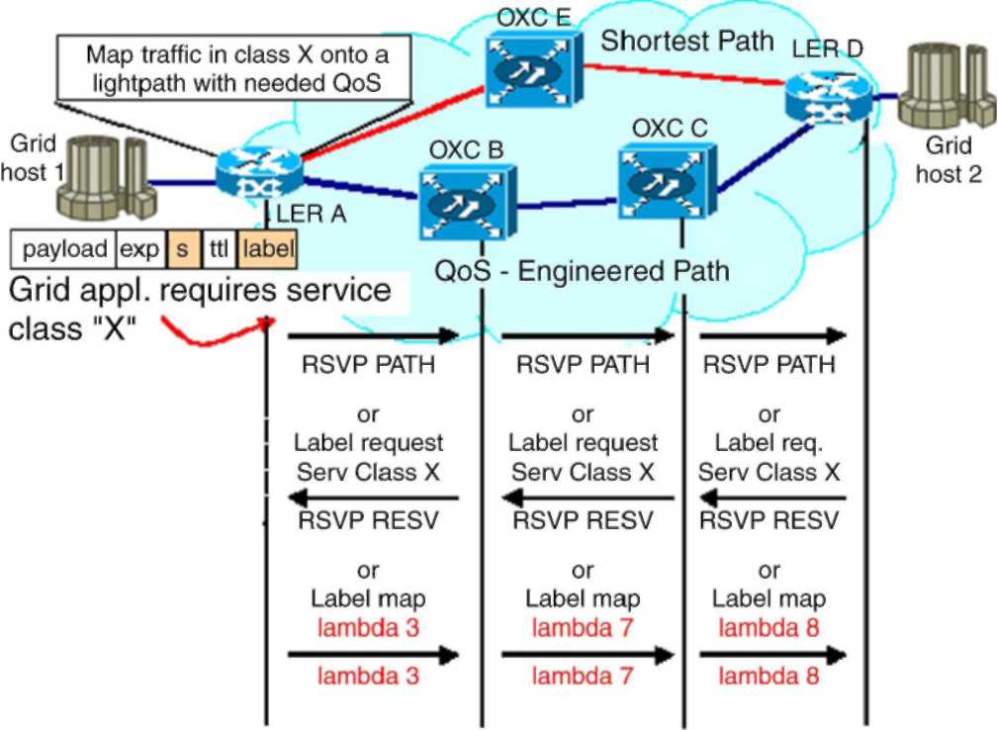
Fig. 2. Lightpath setup with RSVP-TE and CR-LDP.
to the source router. At the destination node, a Resv message is generated to distribute lambdas/labels, and is sent back to the previous node. The intermediate optical nodes reserve the appropriate resources, allocate new wavelengths for the path, modify the resource availability layered graph kept by the RWA protocol and send the Resv message back towards the source router. When the CR-LDP protocol is used for signalling TCP sessions are established between nodes in order to provide a reliable distribution of control messages as depicted in Fig. 2. At the ingress node, a Label Request message is created. The message indicates the route and the required traffic parameters for the route. Resources are reserved at the ingress node, and the Label Request is forwarded to the next node. At the intermediate node, resources are reserved, and the Label Request is forwarded. At the destination, resources are reserved and a wavelength is assigned to the request. The destination node creates a Label Map message which contains the new lambda, and passes the message back towards the source node. Each intermediate node allocates a wavelength, modifies the wavelength resource layered graph and sets up its forwarding table before passing the Label Map to the previous node.
5. Performance evaluation and results analysis
In order to evaluate the performance of the proposed GMPLS/DiffServ-based framework for QoS support in optical Grid networks, an extensive set of simulation experiments has been executed. We used the NIST GLASS simulator, which has been developed for the integrated simulations of Next Generation Internet (NGI) networking with GMPLS-based WDM optical networks. It supports the DiffServ-over-GMPLS paradigm with discrete-event simulations of various DiffServ packet classification, per-hop-behaviour (PHB) processing with class-based-queuing, GMPLS-based signalling (both RSVP-TE and CR-LDP) for WDM optical network and fiber/lambda optical switching. NIST GLASS is implemented on the SSFNet (Scalable Simulation Framework Network) simulation platform based on a flexible Java-based kernel, an open source suite of network component models and a smart management suite. It has been designed and implemented
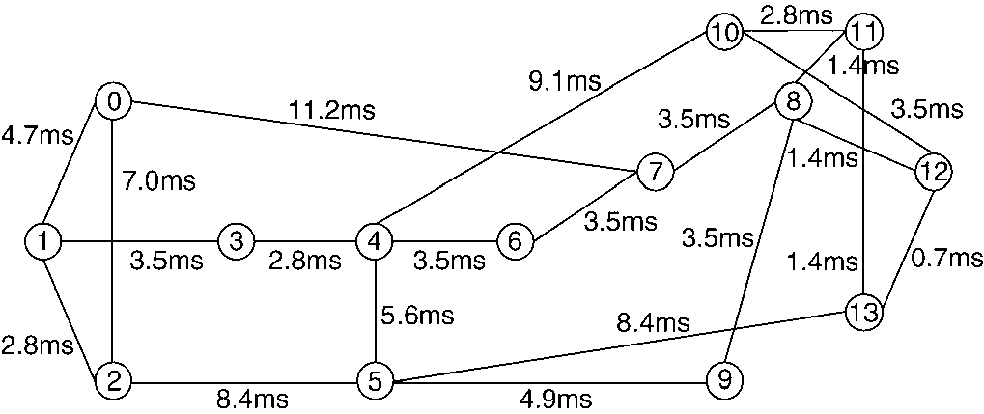
Fig. 3. Sample NSFNet topology used in simulation.
with open interfaces to support expansion or replacement of protocol modules by users. It uses a DML (domain modelling language) description input file interface to support the user's flexible definition/modification of simulation parameters and configuration of protocol modules. Packet classification in SSFNet/GLASS is implemented with a multi-field classifier that uses multiple fields in the IP packet header (DSCP, TOS, source and destination parameters etc.) to determine the differentiated per-PHB treatment for the different traffic classes. We implemented several modifications on the OSPF module according to the multi-layer SPF-based wavelength routing schema described in the previous Section 4 and created some simple stub classes, implemented according to the example presented in Section 3, simulating the GUNI interface for origin and destination traffic, that for simplicity's sake has been classified, by marking it with the proper DSCP values, in two macro categories: high-priority traffic, which requires EF treatment and consequently limited latency, packet loss and jitter, and normal traffic which can be handled according to the BE paradigm with no particular QoS requirements. The stub GUNI interface has also been used to set up bandwidth commitments on the required end-to-end connections. CR-LDP signalling has been used for lightpath set up and wavelength reservation. Simulation has been performed on several network topologies, both with low and high number of nodes, and thanks to the consistency of the results obtained, only the graphs relating to the well-known NSFNet topology reported in Fig. 3 are shown.
The above network consists of 14 nodes and 21 bidirectional links each composed of 8 unidirectional fibers (4 in each direction). There are 16 wavelengths, supporting a bandwidth of 2.5 Gbps, on each fiber; 15 carry data, and one is only used to carry control messages. We assumed that no switches in the network were capable of wavelength conversion. The traffic rate given in [10] is used for an initial traffic matrix, and traffic volumes have been scaled proportionally to the initial distribution. In order to test the guaranteed provisioning of bandwidth and QoS parameters, node 9 on the simulation topology has been chosen to originate most of the traffic load toward the other nodes, thus forcing the creation of two bottlenecks on the links between node 9 and nodes 5 and 8 respectively, through which a very large number of lightpaths is required to pass. The traffic generations have been also imposed with different timing to simulate a gradually fluctuating network condition and the link capacities are configured to be 110% of the sum of the DiffServ packet generation committed
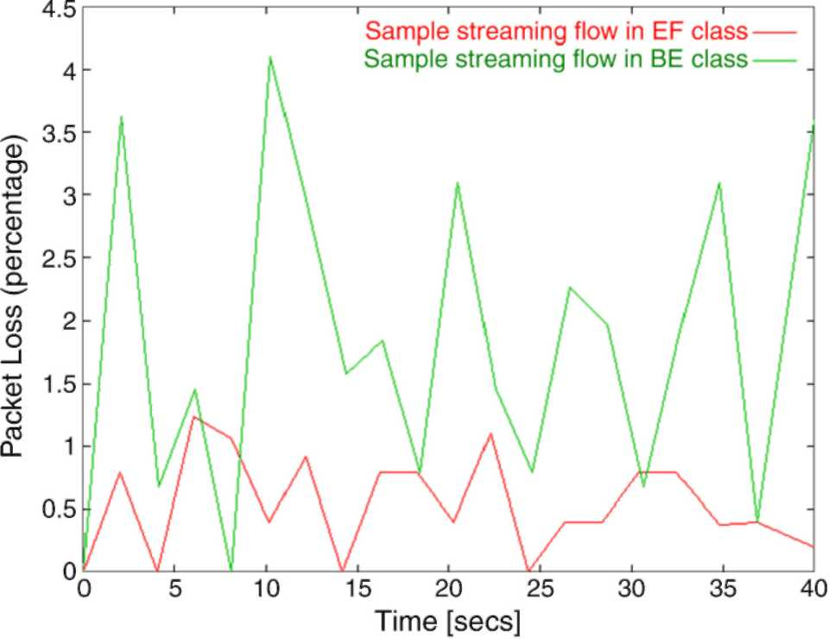
Fig. 4. The packet loss percentage.
data rates; in other words, the link utilization has been kept to 95%. Bandwidth utilization, end-to-end delay, jitter and packet loss ratio have been measured and analyzed under the above traffic conditions for both sample high-priority (EF) and best-effort traffic flows. When analyzing the bandwidth utilization under traffic congestion on the bottleneck links, as expected the committed bandwidth on the packet flows with higher priorities (EF class) was maintained even during congestion and only the lowest priority traffic (BE) was affected, with its data rate reduced proportionally to the load (and the QoS commitments) under congestion. The same considerations may be done on the measured end-to-end delay on the packet flows belonging to the two different DiffServ classes used in our simulation. The higher-priority packet flows were not affected by the congestion status, while the other flows experienced gradually increasing end-to-end delay as the traffic increased through the bottleneck links. Analogously, Fig. 4 shows the average packet loss percentage measured for the two different traffic classes.
The observed packet loss values exactly reflected the basic operational properties of the DiffServ-aware framework where packet loss was kept to the minimum (but not suppressed, due to congestion condition) for the high-priority traffic flows and was sensibly greater (but however not unacceptably high, since we worked on a well provisioned optical network) for BE traffic. Furthermore, to assess the performance of the wavelength routing schema, blocking probability has been analyzed for connections with or without QoS requirements. In the latter case our RWA wavelength selection algorithm has been replaced with the one provided in the usual GLASS OSPF module. Blocking probability has been calculated as a measure of the number of new connection requests that cannot be satisfied because the required resources are not available. We maintained two counters that are updated upon the arrival of each new connection request, one keeping track of the total number of new connection requests, incremented upon the arrival of each new request, and the other tracking the number of failed requests, incremented only when a request fails. The estimated new connection blocking probability is the ratio of
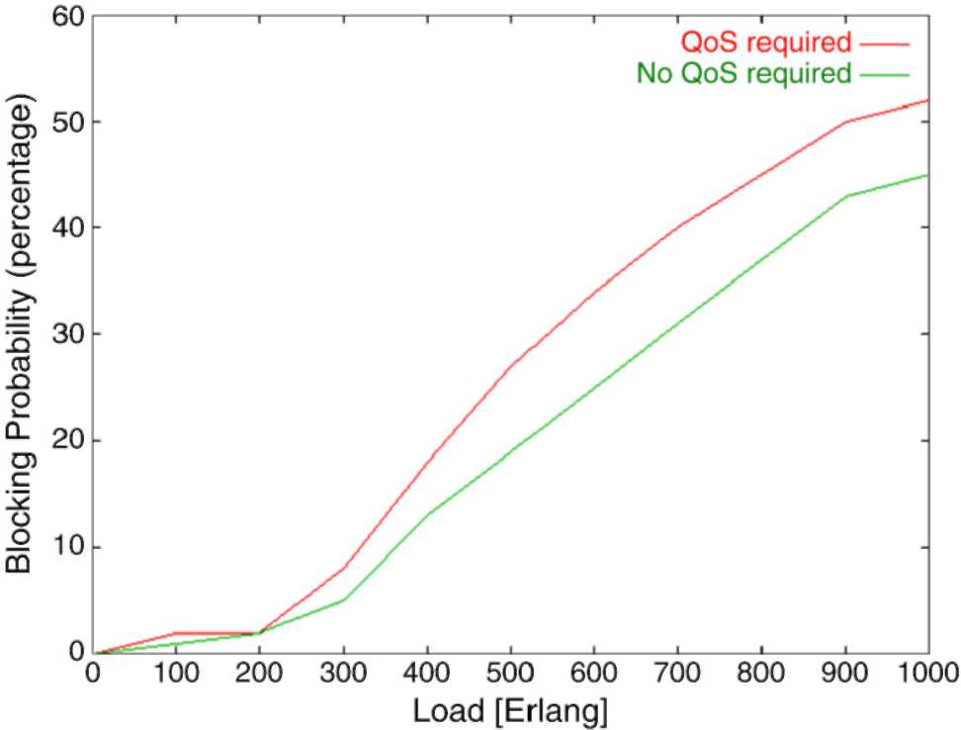
Fig. 5. The blocking probability.
the second counter to the first. It is interesting to observe from Fig. 5 that the measured blocking probability with increasing load does not exhibit significant variations with or without QoS requirements to be satisfied. The blocking probability, when the network load reaches 200 Erlangs and going on, increases almost linearly in both the cases (with a slight difference of about 5%) and at a load of 1000 Erlangs, only about half of new connection requests are honoured (48% with specific QoS requirement and 55% in the other case). This is a very strong performance indicator for the QoS-driven wavelength selection paradigm, since the small difference shown at higher loads can be justified by the decreasing resource availability, thus it can be easily seen that the DiffServ-based RWA framework imposes no significant overhead in terms of blocking probability.
6. Related works
Several works focus on providing optical networks to the Grid community [16,17] and recently, Grid developers used both IntServ and DiffServ approaches to obtain QoS in packet switching networks [18-21]. However, IntServ and DiffServ alone may help in some special cases, but they are far from perfect solutions, particularly in wavelength switched optical networks that add further technological complexity to the already existing integration and interface problems. Some work has been done in defining an OGSA-based network service interface to network resources. Another related work is the DWDM-RAM project [22] that encapsulates optical network resources (lambdas, lightpaths) into a Grid Service and thus integrates their management in the context of the OGSA Architecture. A better approach to the problem of network resource management in Grids have been introduced with the General-purpose Architecture for Reservation and Allocation (GARA) [23]. GARA addresses the issue ofadvance reservation by proposing a common framework that can be applied to different resource types such as computing, storage and networking. Resource management is integrated with a variety of general-purpose Grid services (e.g., for authentication and authorization). However, GARA identifies the network devices involved in the reservation requests statically through configuration files. Consequently, there is no way for a Grid customer to dynamically discover the entire range of available network reservation services. Although advanced bandwidth and QoS reservation is an issue, access to resources that provides these features solves only one part of the problem. The complete solution is a new network architecture with the ability to orchestrate data flows with many different types of QoS characteristics or service classes, including those requiring exceptionally high bandwidth or very limited packet loss and/or jitter for sustained periods of time. In our model, these high-performance data flows are provided by dedicated optical paths, which are dynamically allocated on a class of service basis.
7. Conclusions
We investigated the problem of QoS delivery in the future wavelength routed networks and presented a general framework for providing differentiated services QoS to support real-time Grid applications in wavelength-routed photonic networks built on the strengths of GMPLS for dynamic path selection and wavelength assignment. The integration of Grid architectural concepts with those emerging from next generation optical networking has just begun. The concept of optical-network-aware Grid applications signalling, within the GUNI interface context, their QoS requirements to an intelligent, dynamically configured wavelength-based network, complements the overall objectives and direction of Grid architecture. This type of integration would provide Grid communities with powerful new global data path Differentiated Service QoS capabilities. GMPLS provides the necessary bridges between the IP and optical layers to allow for interoperable and scalable parallel growth in the IP and photonic dimension so that the capabilities offered by the combination of Differentiated Services and GMPLS features greatly enhance the ability to control the network to deliver service according to the Grid end-to-end application Service Level Agreements and strict QoS requirements.
References
[1] E. Mannie, Generalized multi-protocol label switching (GMPLS)
architecture, in: IETF RFC 3945, 2004. [2] I. Foster, C. Kesselman, The Grid: Blueprint for a Future Computing
Infrastructure, Morgan Kaufmann, Los Altos, CA, 1999.
[3] D.A. Reed, Grids, the TeraGrid and beyond, Computer 36 (1) (2003)
62-68.
[4] J. Mambretti, J. Weinberger et al., The Photonic TeraStream: enabling next generation applications through intelligent optical networking at iGRID2002, Future Generation Computer Systems 19 (2003) 897-908.
[5] R. Braden et al., Integrated services in the internet architecture: an overview, in: IETF RFC 1633, 1994.
[6] S. Blake et al., An architecture for differentiated services, in: IETF RFC 2475, 1998.
[7] R. Braden, L. Zhang, S. Berson, S. Herzog, S. Jamin, Resource reservation protocol (RSVP) — Version 1 functional specification, in: IETF RFC 2205, 1997.
[8] B. Jamoussi et al., Constraint-based LSP setup using LDP, in: IETF RFC 3212, 2002.
[9] M. Kodialam, T.V. Lakshman, Integrated dynamic IP and wavelength routing in IP over WDM networks, in: Proceedings of INFOCOM 2001, vol. 1, 2001, pp. 358-366.
[10] R. Ramaswami, K.N. Sivarajan, Design of logical topologies for wavelength-routed optical networks, IEEE Journal on Selected Areas in Communications 14 (1996) 840-851.
[11] I. Foster, C. Kesselman, J. Nick, S. Tuecke, The Physiology of the Grid: An Open Grid Services Architecture for Distributed Systems Integration, Globus Project, http://www.globus.org/research/papers/ogsa.pdf, 2002.
[12] K. Czajkowski et al., From Open Grid Services Infrastructure to WS-Resource Framework: Refactoring and Evolution, http://www.globus.org,
2004.
[13] A. Saleh et al., Proposed extensions to the UNI for interfacing to a
configurable all-optical network, in: OIF2000.278, 2000. [14] B. Rajagopalan et al. (Eds.). User network interface (UNI) 1.0 signaling
specification, in: OIF2000.125.3, 2000. [15] A. Iamnichi, I. Foster, On fully decentralized resource discovery in Grid
environments, in: International Workshop on Grid Computing, in: LNCS,
vol. 2242, 2001, pp. 51-62. [16] L. Smarr et al., The OptIPuter, Communications of the ACM 46 (11)
(2003) 58-67.
[17] D. Vanderster, The Return of circuit switching: A review of user-controlled lightpaths for Grid computing, Technical Report, University of
Victoria, Canada, 2003.
[18] I. Foster et al., End-to-end quality of service for high-end applications,
in: Network Support for Grid Computing, Computer Communications
(2002) (special issue). [19] I. Foster et al., A quality of service architecture that combines resource
reservation and application adaptation, in: 8th International Workshop on
Quality of Service, 2000. [20] G. Hoo et al., QoS as middleware: Bandwidth reservation system design,
in: Proceedings of the 8th IEEE Symposium on High Performance
Distributed Computing, 1999, pp. 345-346.
[21] V. Sander et al., A differentiated services implementation for high-performance TCP flows, Elsevier Computer Networks 34 (2000)
915-929.
[22] A. Roy, V. Sander, GARA: a uniform quality of service architecture, in: J. Nabrzyski, J.M. Schopf, J. Weglarz (Eds.), Grid Resource Management: State of the Art and Future Trends, Kluwer Academic Publishers, 2003, pp. 377-394.
[23] D.B. Hoang, H. Cohen, D. Cutrell, S. Figueira, T. Lavian, J. Mambretti,
I. Monga, S. Naiksatam, F. Travostino, DWDM-RAM: An architecture for data intensive service enabled by next generation dynamic optical networks, in: Proceedings of IEEE Globecom 2004, Workshop on High-Performance Global Grid Networks, Houston, 2004.
Francesco Palmieri holds two Computer Science degrees from Salerno University, Italy. From 1989, he worked for several international companies (i.e. Alcatel, TeleSoft) on a variety of networking-related projects, concerned with nation-wide communication systems, network management, transport protocols, and IP networking. Since 1997 he has led the network management/operation center of the Federico II University, in Napoli, Italy. He has been closely involved with the development of the Internet in Italy in recent years, particularly within the academic and research sector, as a member of the Technical Scientific Committee and of the Computer Emergency Response Team of the Italian Academic and Research Network GARR. He is an active researcher in the fields of high-performance/evolutionary networking and network security. He has published several papers in leading technical journals and at conferences and given invited talks and keynote speeches. He can be reached at Francesco.Palmieri@unina.it.


